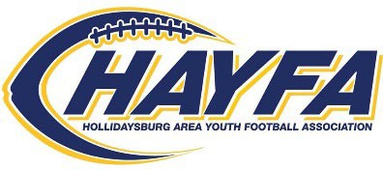
P.O. Box 96
Hollidaysburg, PA 16648 www.hayfa.us

PLEASE INCLUDE CONTACT INFORMATION BELOW AND SELECT YOUR CONTRIBUTION LEVEL.

BUSINESS NAME: CONTACT NAME: ADDRESS: PHONE: EMAIL:
- WALTER PAYTON CONTRIBUTOR- $750.00
Includes full page advertisement in all HAYFA Game Day Program Guides, banner prominently displayed at Tiger Stadium on game day every Saturday, sponsorship announced at games, company logo scrolling on HAYFA webpage as a HAYFA sponsor and one featured social media shout-out.
- HEISMAN CONTRIBUTOR- $500.00
Includes full page advertisement in all HAYFA Game Day Program Guides, banner prominently displayed at Tiger Stadium on game day every Saturday, sponsorship announced at games, company logo on HAYFA webpage as a HAYFA sponsor.
- LOMBARDI CONTRIBUTOR- $250.00
Includes half page advertisement in all HAYFA Game Day Program Guides, sponsorship announced at games
- OUTLAND CONTRIBUTOR- $125.00
Includes quarter page advertisement in all HAYFA Game Day Guides, and sponsorship announced at games
- TIGER FRIENDS- $50.00
Includes business card advertisement in all HAYFA Game Day Guides

Please return the enclosed form along with your contribution and any advertisement made payable to: HAYFA in the self-addressed stamped envelope.

Questions, please reach out to:
Anne Hoffman – HAYFA Board President
hayfatreasurer@gmail.com
Megan Fickes – HAYFA Board Vice President
Megan72980@gmail.com

THANK YOU FOR YOUR SUPPORT!!!
Sponsorship must be submitted by May 15th

